Sales Trend Analysis

select * from sales_transactions;
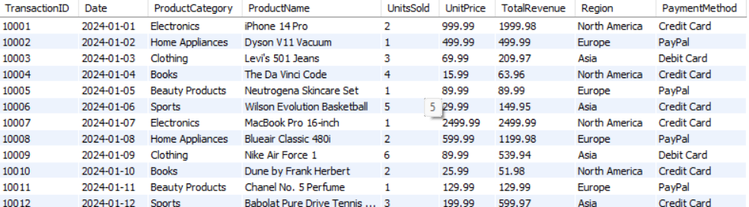

1. select sum(totalrevenue) as TotalRevenue
from sales_transactions;
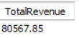

2. select sum(unitssold) as QuantitySold
from sales_transactions;
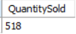

3. select date_format(Date,"%M") as MonthName, sum(totalrevenue) as TotalRevenue
from sales_transactions
group by date_format(Date,"%M")
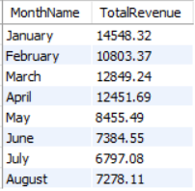

4. select dayname(date) as Day, sum(unitssold) as QuantitySold
from sales_transactions
group by dayname(date)
order by sum(unitssold) desc;
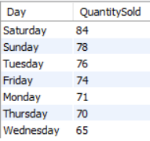

5. select quarter(date) as Quarters, sum(totalrevenue) as TotalRevenue
from sales_transactions
group by quarter(date)
order by sum(totalrevenue) desc;
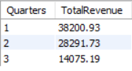

6. with monthlysales as (
select date_format(Date,"%M") as MonthName, MONTH(Date) AS MonthNumber , sum(totalrevenue) as TotalRevenue
from sales_transactions
group by date_format(Date,"%M") , MONTH(Date)
)

select MonthName,TotalRevenue,
lag(TotalRevenue) over(order by MonthNumber) as PreviousMonthSales,
round((TotalRevenue - lag(TotalRevenue) over(order by MonthNumber) ) *100/lag(TotalRevenue) over(order by MonthNumber),2) as MontlyGrowth
from monthlysales

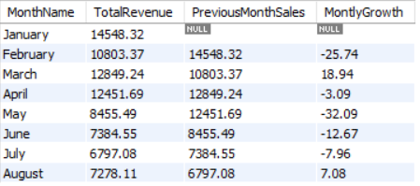

7. with quarterlysales as (
select quarter(date) as Quarters, sum(totalrevenue) as TotalRevenue
from sales_transactions
group by quarter(date)
order by sum(totalrevenue) desc
)
select Quarters,TotalRevenue,
lag(totalRevenue) over(order by Quarters) as PreviousQuarterSales,
round((TotalRevenue - lag(totalRevenue) over(order by Quarters)) * 100 / lag(totalRevenue) over(order by Quarters),2) as QuaterlyGrowth
from quarterlysales;
